**Title of Project \**

**Autonomous Home Controller**

**Project Exhibition -2**

Submitted in partial fulfillment for the award of the degree of

**Bachelor of Technology**

**In**

**DEPARTMENT OF ELECTRICAL AND ELECTRONICS ENGINEERING**

Submitted to

**VIT BHOPAL UNIVERSITY (M.P.)**



**Submitted by**

**NAME OF STUDENT- REGISTRATION0 NO**

**YASH CHANDAK – 20BAC10026**

**ANIKET VERMA – 20BAC10042**

**SHIVAM LANDGE– 20BAC10046**

Under the Supervision of

GUIDE NAME

DR.CHANDAN KUMAR

**SCHOOL OF ELECTRICAL & ELECTRONICS ENGINEERING**

**VIT BHOPAL UNIVERSITY**

**BHOPAL (M.P.)-466114**

**Month –Year - MAY2022**

© VIT Bhopal University – Year 2022



**VIT BHOPAL UNIVERSITY BHOPAL (M.P.) 466114**

SCHOOL OF ELECTRICAL & ELECTRONICS ENGG.

**CANDIDATE’S DECLARATION**

I hereby declare that the Dissertation entitled “*AUTONOMOUS HOME CONTROLLER*” is my own work conducted under the supervision of *DR CHANDAN KUMAR* at VIT Bhopal University, Bhopal.

I further declare that to the best of my knowledge this report does not contain any part of work that has been submitted for the award of any degree either in this university or in other university / Deemed University without proper citation.

*YASH CHANDAK- 20BAC10026*

*ANIKET VERMA – 20BAC10042*

*SHIVAM LANDGE –20BAC10046*

This is to certify that the above statement made by the candidate is correct to the best of my knowledge.

Date:8/5/2022

Guide Name – DR CHANDAN KUMAR

Digital Signature of Guide

--------------------------------------------------------



**VIT BHOPAL UNIVERSITY, Bhopal**

SCHOOL OF ELECTRICAL & ELECTRONICS ENGINEERING

**CERTIFICATE**

This is to certify that the work embodied in this project report entitled **“AUTONOMOUS HOME CONTROLLER”** has been satisfactorily completed by **Mr. YASH CHANDAK (20BAC10026),ANIKET VERMA (20BAC10042)**, **SHIVAM LANDGE (20BAC10046)** in the School of Electrical & Electronics Engineering of at VIT Bhopal University, Bhopal. This work is a bonafide piece of work, carried out under my/our guidance in the School of for the partial fulfilment of the degree of Bachelor of Technology.

|  |  |
| --- | --- |
|  | ***Name of Guide***  ***DR.CHANDAN KUMAR*** |
|  |
|  |  |
| Forwarded by | Approved by |
|  |  |
| ***DR.SOUMITRA K NAYAK*** | ***Dr. D.ADHIKARY*** |
| **Program Chair** | **Associate Professor & Dean** |

**Acknowledgement**

In the first place I would like to record my gratitude to “***DR.CHANDAN KUMAR*”** for his supervision, advice, and guidance from the very early stage of this thesis work as well as giving me extraordinary experiences throughout the work. Above all and the most needed, he provided me unflinching encouragement and support in various ways. His words have always inspired me to work in an efficient and comprehensive way. I would like to thank him for his constant encouragement that enabled me to grow as a person. His presence has definitely improved me as a human being.

I express my gratitude towards “**Dr. D.ADHIKARY** Professor and Dean of School of Electrical and Electronics Engineering Department, VIT Bhopal University, Bhopal, for providing me all the help and permitted me to work in the laboratory with no time limits.

I shall ever remain indebted to “**Dr. U Kamachi Mudali”,** Vice Chancellor, VIT Bhopal University,for providing me institutional and administrative facilities during my project work at VIT.

I am very thankful to all

**Executive Summary**

Home Appliances Controlling using Bluetooth project is a fine combination of Android mobile technology and embedded system.The user can control Home appliances using Android mobile. An Android application should be installed on his/her Android mobile handset to control various home appliances.

**List of Figures**

|  |  |  |
| --- | --- | --- |
| Figure No. | Caption / Title |  |
| 2.1 | AUTONOMOUS HOME CONTROLLER ARCHITECTURE |  |
| … |  |  |
| 3.2  3.3  3.4 | FLOWCHART AND WORKING METHODOLOGY  READING INPUT AURDINO APPLICATION  READING OUTPUT FROM SYSTEM |  |
|  |  |  |

**List of Tables**

|  |  |  |
| --- | --- | --- |
| Table No. | Caption / Title |  |
| 3.1 | **INTRODUCTION** |  |
| . . . |  |  |
| 3.2  3.4  3.5  3.6  3.7 | LIST OF COMPONENT USED  OBJECTIVE  LITERATURE REVIEW  METHODOLOGIES  CONCLUTION |  |

**Table of Contents**

Front Page ii

Candidate’s Declaration iii

Certificate iv

Acknowledgement v

Executive Summary vi

List of Figures vii

List of Tables viii

List of Symbols & Abbreviations ix

.

**INTRODUCTION:**

Home automation is building automation for a home, called a smart home or smart house. A home automation system will monitor and/or control home attributes such as lighting, climate, entertainment systems, and appliances. It may also include home security such as access control and alarm systems. When connected with the Internet, home devices are an important constituent of the Internet of Things ("IoT").

A home automation system typically connects controlled devices to a central smart home hub (sometimes called a "gateway"). The user interface for control of the system uses either wall-mounted terminals, tablet or desktop computers, a mobile phone application, or a Web interface that may also be accessible off-site through the Internet.

While there are many competing vendors, there are increasing efforts towards open source systems. However, there are issues with the current state of home automation including a lack of standardized security measures and deprecation of older devices without backwards compatibility.

Home automation has high potential for sharing data between family members or trusted individuals for personal security and could lead to energy saving measures with a positive environmental impact in the future.

**List of Symbols & Abbreviations**

1. **ARDUINO**
2. **4 WAY RELAY**
3. **BREAD BOARD**
4. **JUMPER WIRE**
5. **HC – 05 BLUETOOTH MODULE**
6. **5 VOLT POWER SUPPLY**
7. **SMARTPHONE**

**OBJECTIVE**

* **Home Appliances Controlling using Bluetooth project is a fine combination of Android mobile technology and embedded system.**
* **The user can control Home appliances using Android mobile. An Android application should be installed on his/her Android mobile handset to control various home appliances.**
* **The user can send commands using that application.**
* **This project consists of a Bluetooth receiver.**
* **This Bluetooth device is connected to the circuit which has a decoder.**
* **This decoder sends a code for the respective command sent by the user. Then the respective device connected to the circuit will be turned on or off depending on the command given.**
* **At the output side of Home Appliances Controlling using Android Mobile via Bluetooth, we have connected 4 relays.**

**LITERATURE REVIEW**

**Design and Implementation of a Microcontroller Based Home Automation System Using “MIT Remote App”, explore the use of television remote to control home appliances, this is not efficient as users have to be physically present to activate the system by pointing the remote towards the appliance**

* + **This paper is written to implement a smart home automation system with enhanced authorisation and security practices, considering the detailed description of different technologies present nowadays**
  + **This work is done by keeping in mind the various smart home systems like central controller-based smart home systems, Bluetooth-based smart home systems and Internet-based smart home systems. The work is concluded by giving future directions smart home Security Research**

**METHODOLOGY**

1. **Firstly, Arduino is powered through a 5V supply(or a laptop).**
2. **Arduino is programmed via ARDUINO IDE software on the laptop.**
3. **HC-05 bluetooth module is connected to Arduino board via jumper wires.**
4. **Further, arduino is connected to the relay board via jumper wires.**
5. **Now, one of the wire of the home appliance(LED Bulb) is connected to the relay board whereas the other wire is connected to power supply.**
6. **A single piece of wire is connected from relay board to the power supply.**

**Flowchart for working methodology:**

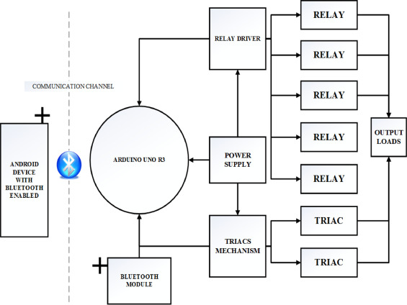

**SOFTWARE WORKING:**

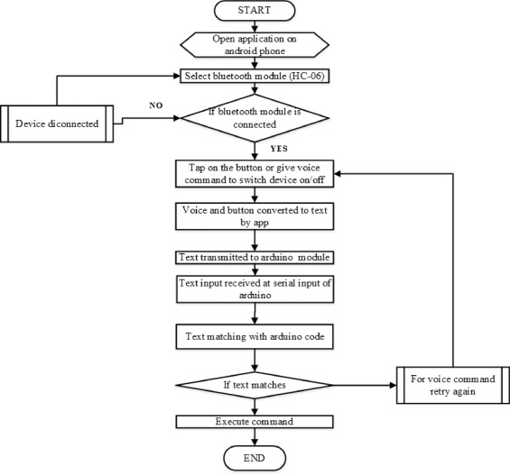

Arduino IDE

The Arduino IDE is an open-source software that writes, compiles, and upload codes directly into the microcontroller. The version used in this paper is version 1.8.9. The Arduino IDE environment is used for writing the desired software code and for compiling, uploading code into the given Arduino board. Its environment supports both C and C++ language. It is also used for debugging, editing, compiling, and uploading code in its environment to physical hardware modules.

Proteus IDE

Proteus IDE is a virtual system modeling (VSM) and circuit simulation application software. It also has a virtual system studio, a free universal IDE for Proteus. Also, Proteus VSM can be used for advanced embedded simulation, offering-system level simulation based on the schematic circuit. It has a wide range of components in its database or library. Besides its own database component, more components can be designed as part of the library component if they are not part of the original software library. Such a library component includes Arduino and Bluetooth Library for Proteus, etc.

MIT app inventor 2

The android developing platform MIT app inventor 2 is the latest version of an online app used in developing android applications. It contains blocks that are dragged and dropped at the desired blocks in the corresponding place. The developed Application can be installed on an Android phone/tablet with a Bluetooth module. shows code blocks for Bluetooth connection and voice recognition, relay switch respectively.

**TESTING AND WORKING** :

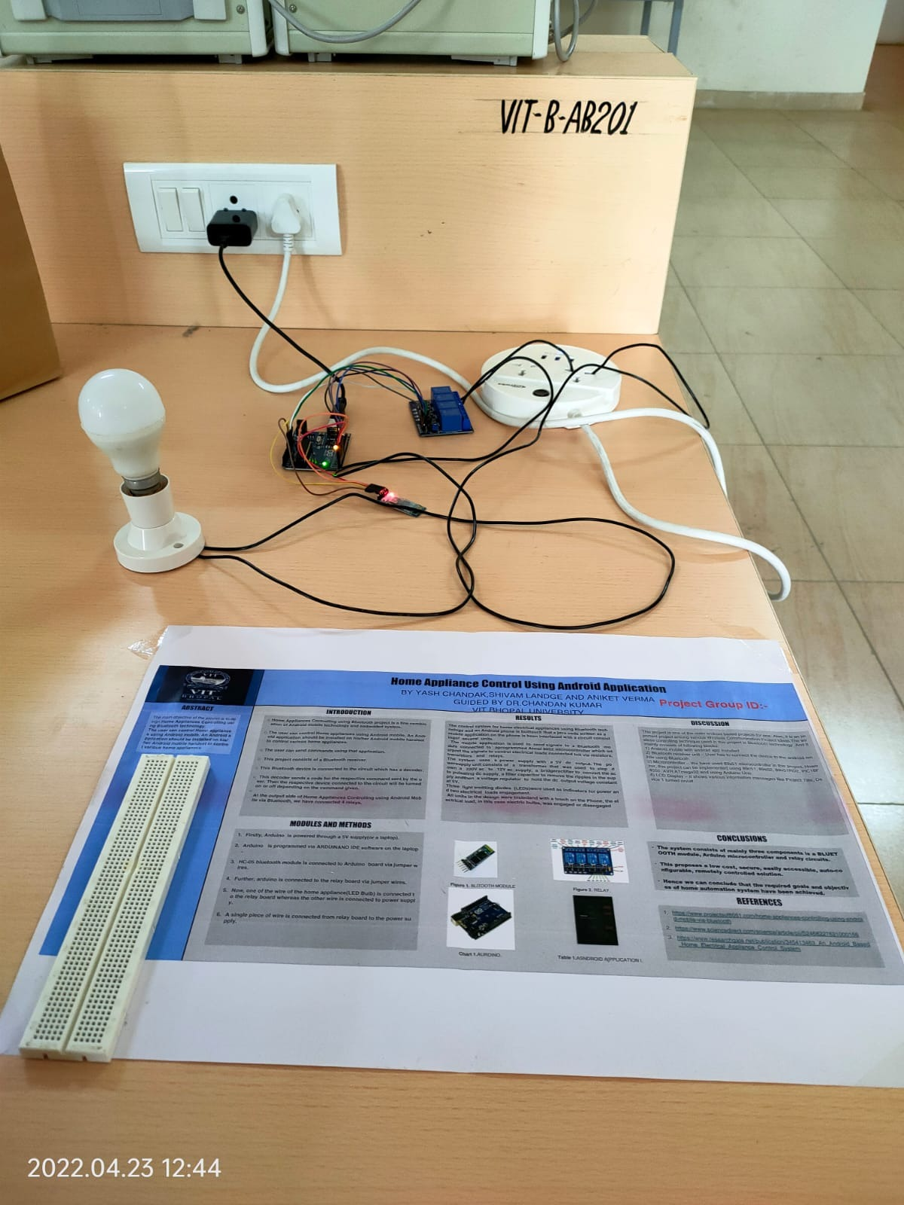

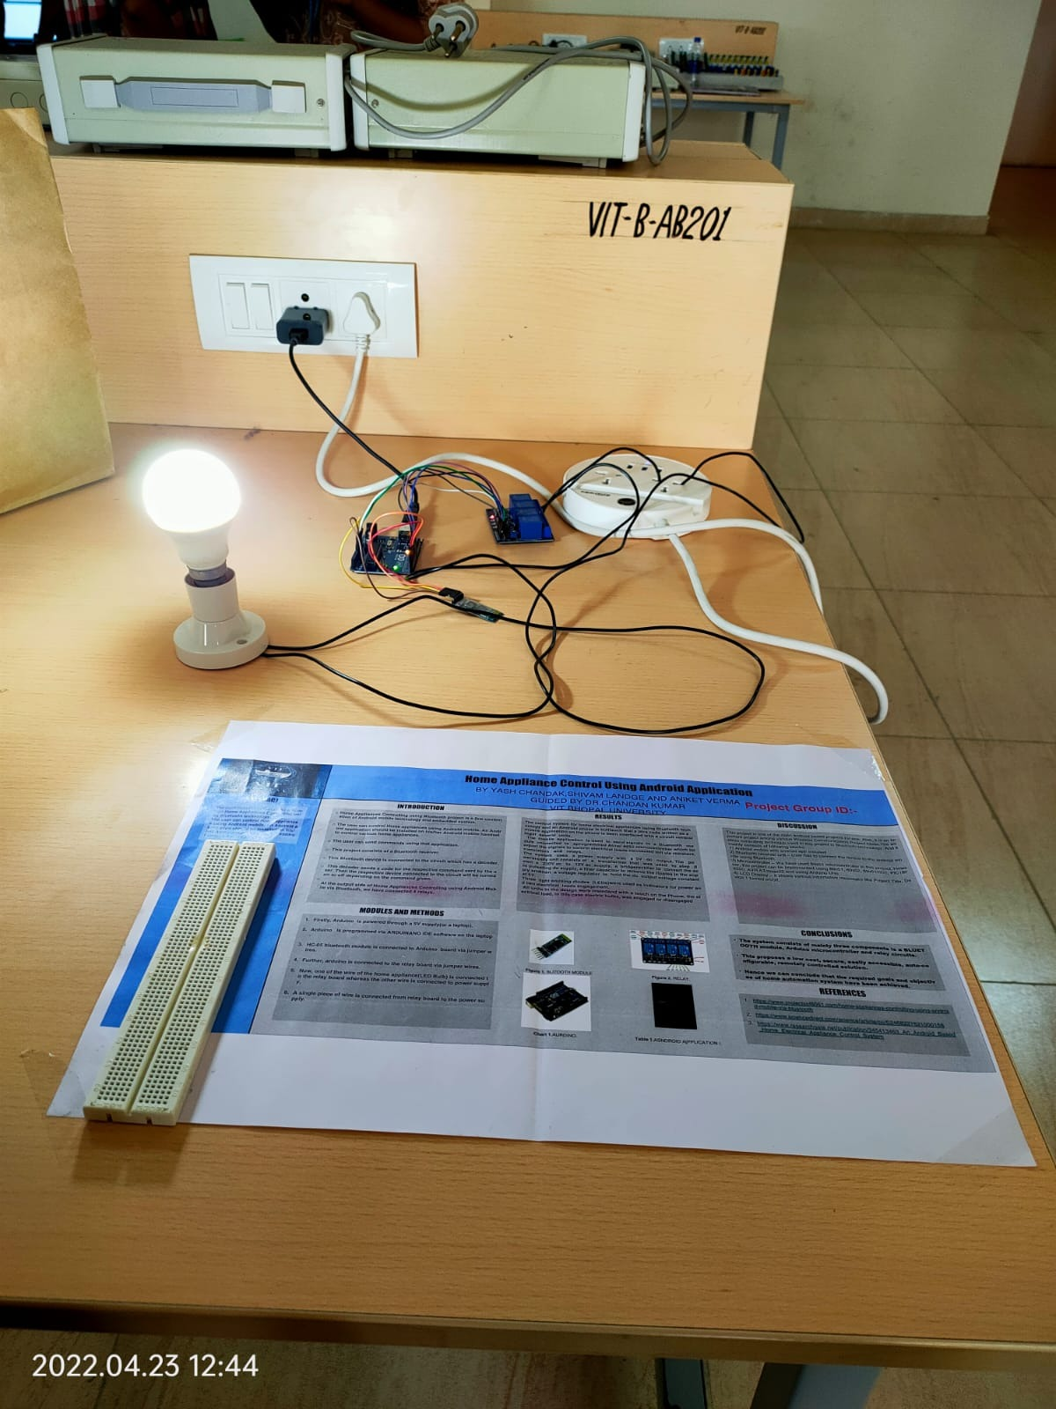

**Conclusion and future work**

An Arduino based home automation system using Bluetooth and an android application with voice command has been designed and implemented.

The Home automation system used an Android application and a Bluetooth technology in the design; this is because they are easy to use, fast, readily available, and reliable in communications between the remote user and devices.

A low cost and highly reliable home automation system that can assist handicapped/old aged people, as well as a user-friendly device was developed. Other features can be added in the future such as biometrics so that unauthorised persons can not have access to the appliances and an also timing schedule can developed for each appliances connected this will effectively conserve energy.